Script duplicate issue:
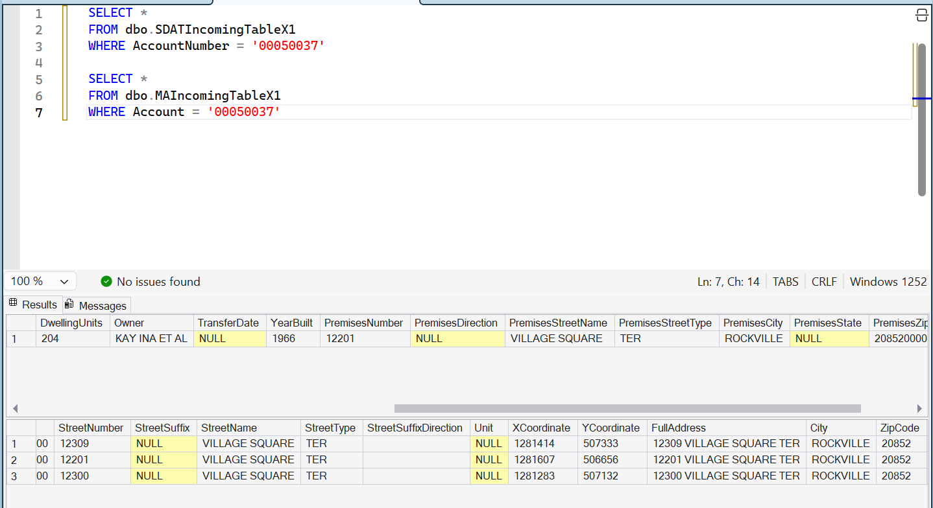

Building below in row 3 has 2 units (row 4 & 5) should have been 1 unit. Same Account # in SDAT & MA for building address 12201 Village Square Ter, Rockville. Since that address is duplicate, we take one. Script treated both in SDAT & MA making the 2 units instead of 1. Do you get my point? Script needs to really watch for this kind of duplicate and treat as one record.

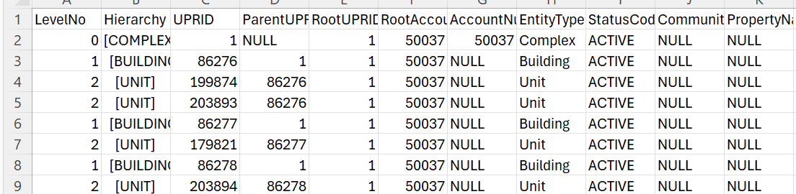

Same Account # and address duplicate issue 2:

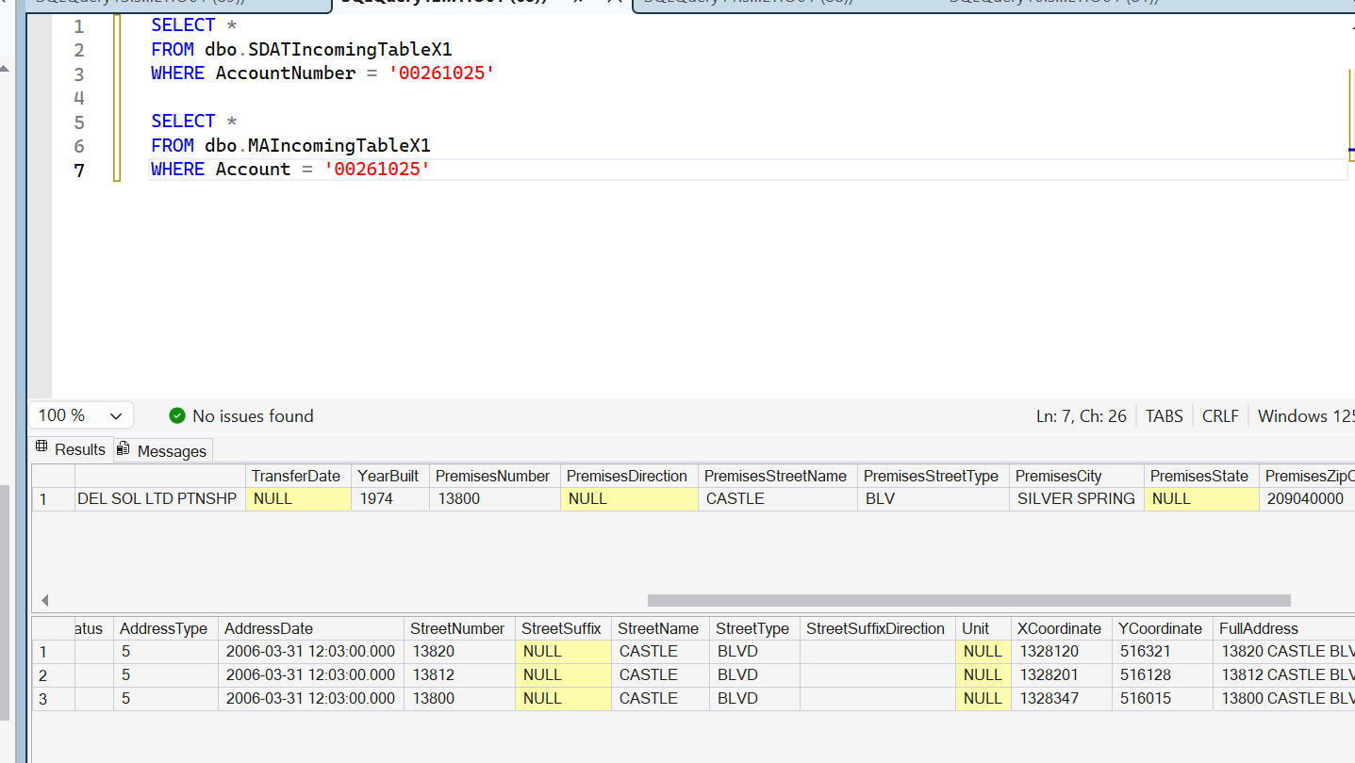

Should have 3 buildings and 3 units. 4th was duplicate.
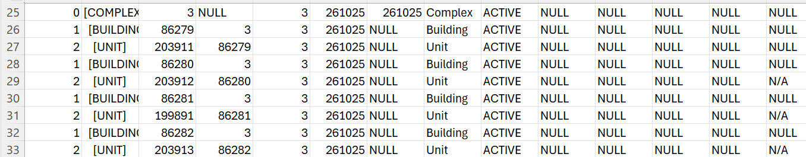

These below were treated well: Good job!!! Showing for contrast.
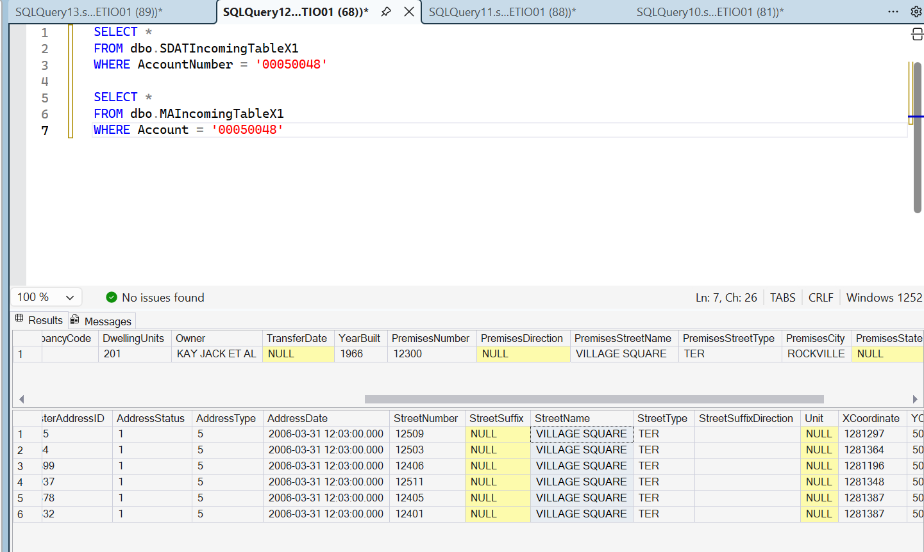

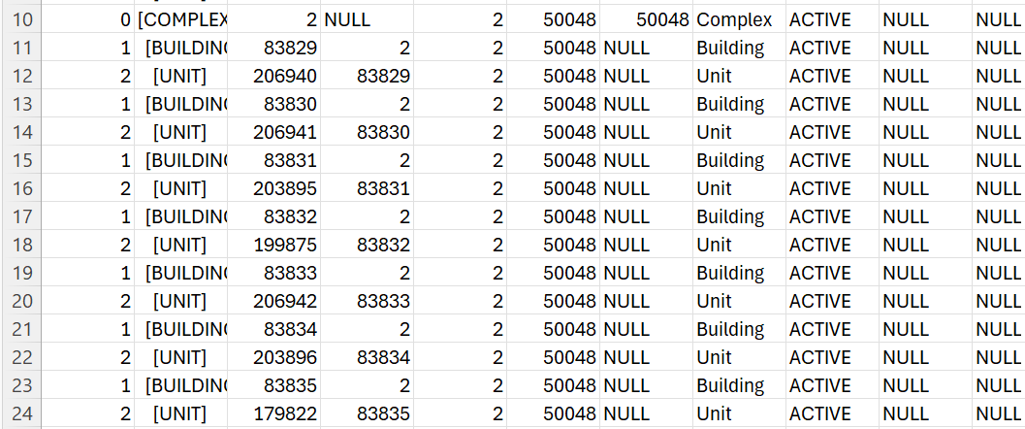

Below ok too.
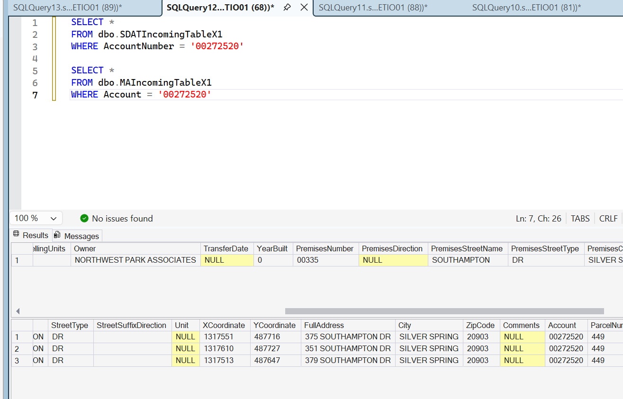

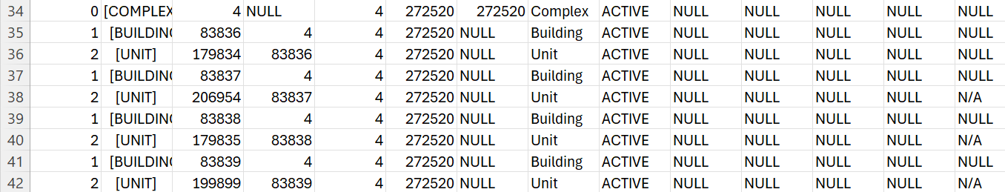

Other Changes:
- Condo table:
- Remove Condo Name and Parcel columns from it

- UPR_Closure
- Change column name “AncestorUPRID” to “UPRAncestry”

- AuditLog
- Include UPRID column to identify the audited UPR record
- Change EntityName to EntityNameID ( FK) to reference a separate Entity_Name table rather than string-searching entity names in a large audit table.

AUDIT_LOG
Audit Log then references REF_ENTITY_IDENTIFICATION.
Column | Data Type | Null? | Key / Constraint | Description
AuditLogID | BIGINT | No | PK | Unique audit event
UPRID | BIGINT | Yes | FK → UPR | UPR associated with the change
EntityID | INT | No | FK → REF_ENTITY_IDENTIFICATION | Type of entity being audited
EntityRecordID | BIGINT | No |  | ID of the actual record changed
ActionType | VARCHAR(20) | No |  | INSERT, UPDATE, DELETE
ChangedDate | DATETIME2 | No |  | Date/time of change
ChangedBy | VARCHAR(100) | No |  | User/process that made the change
OldValues | NVARCHAR(MAX) | Yes |  | Values before change
NewValues | NVARCHAR(MAX) | Yes |  | Values after change

REF_ENTITY_IDENTIFICATION
This is the reference table that identifies what entity a record represents.
Column | Data Type | Null? | Key / Constraint | Description
EntityID | INT | No | PK | Unique identifier for the entity definition
EntityName | VARCHAR(100) | No | UNIQUE | Name of the entity, e.g. UPR, PROPERTY, BUILDING, UNIT
EntityDescription | VARCHAR(250) | Yes |  | Description of the entity
IsActive | BIT | No |  | Indicates whether the entity is available for auditing
CreatedDate | DATETIME2 | No |  | Reference record creation date
CreatedBy | VARCHAR(100) | No |  | User/process creating the reference record

